1] in re E'^°•.'≈^[‘|•|’]]±O@N-T-F-S;S-U-T-R-O-N;U-N-I-X;CTRL+A-M-I-G-A;fx^3;F-X-^-3.//.

2] in re Sensor_SOLD/SUTRON963.9 = [sic][NONE];

3] in re Sensor_SOLD/Non-SUTRON963.9 = [sic][x(tm)];

4] in re Paradigm/SCHOOLING/ YEARS = [sic][y(tm@-540—1088±O/:ohiscot13/m-i-n-gsystemsltd.git/*.*io[]]^’|°•.|')];

5] in re Paradigm/Certification(s)/ YEARS [}S.S.:x_______][sic][z(tm)];

6] in re Paradigm/EMPLOYMENT/ YEARS [=NOT}S.S.:x________][sic][xyz(tm))];

7] in re Paradigm/CURRENT_EMPLOYMENT+ [sic][xyz(tm)];

---> [7-8-9] = (8+)=[=NOT2LOCK]=[=NOT2JAM[B]]=+FISA@+F.B.I.]=[sic];(x____)

9] in re PARADIGM_FUTURE/+PRESENT/WORK<SYMBOL=NOT/><SYMBOL=NOTdots+SYMBOL=NOTsign>

10] in re VERIFICATION/CURRENT_SCHOOLING[sic][}S.S.:x_______];

11] in re VERIFICATION/CURRENT_EDUCATION[sic][}S.S.:x_______];

.12] in re FAT 32;

.12A] +1] in re N-T-F-S;

.12B] FIGURE <Floating_Point=NOT*> ILLUSTRATION[sic](s);

.12C] FALSE+ = N-T-F-S <=NOT> FAT32 IN ERROR of

.12C+1] VIOLATION of SENSOR MANUAL 8800-1173 at

.12C+2] SUTRON<Degree0/SuperScript>VR+ SUTRON<Degree01/SuperScript>=<NOT>VR+SUTRON<Degree01/SuperScript>VR

.12C+2<Degree0>]SUTRON-<Degree0/SuperScript>VR+ SUTRON963.9+=[=NOTSUTRON963.9_]//

•.13] in re FAT 16;

•.13A] +1] in re N-T-F-S;

•.13B] FIGURE <Floating_Point=NOT*> ILLUSTRATION[sic](s);

•.13C] FALSE+ = N-T-F-S <=NOT> FAT16 IN ERROR of

•.13C+1] VIOLATION of SENSOR MANUAL 8800-1173 at

•.13C+2] SUTRON<Degree0/SuperScript>VR+ SUTRON<Degree01/SuperScript>=<NOT>VR+SUTRON<Degree01/SuperScript>VR

•.13+2<Degree0>]SUTRON-<Degree0/SuperScript>VR+ SUTRON963.9+=[=NOTSUTRON963.9_]//

14] as --->[7-8-9];

15] in re Bank\Account(s).;

16] in re Attorney-in-fact viade Apostille_Convention/+//ESKOM/[sic];

17] in re Organized.org(c)2010, 2016/[sic];

18] in re Insurance.+(tm)sic];

19] in re Space_Treaty_Law 2002,(tm)1994(c)2010[2013]2014, 2016;

20] [UNKNOWN]

21] [UNKNOWING]

4:24PM 9/6/2017,1/14/2018

10:30PM 6/5/2023 © Reference ID±O@sao@ucsb.edu.:

Begin.

>>>>E°•.°•.≈EOF<<<<

(CE);

CE;

CE°•.+['|•|']]^°•.84@O*,*io[['|•|']

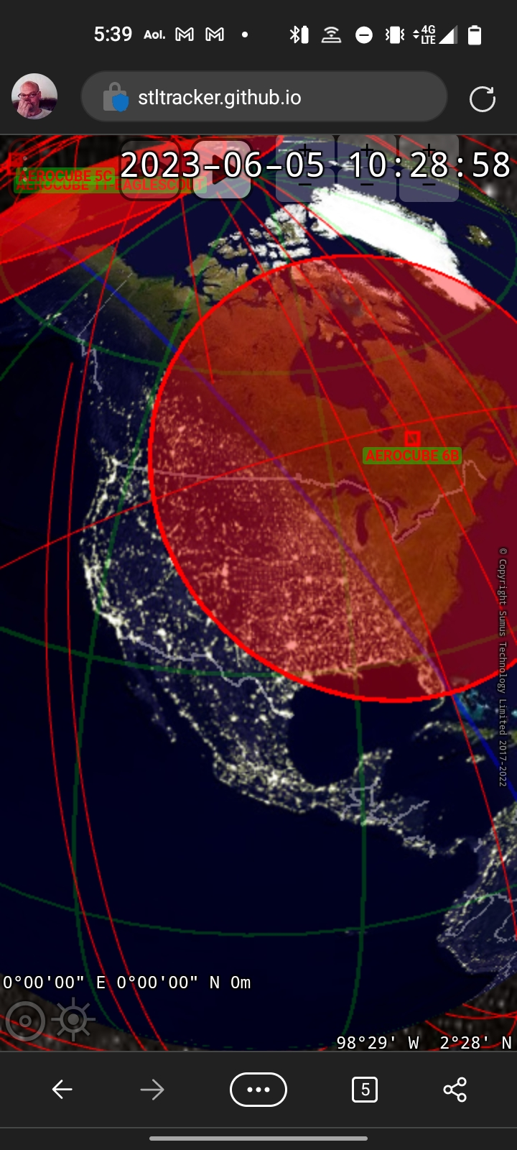(

); NB≈[CE°•.+[←←]’|•|’]^°•.84@^EEOF ASIS ACCOMODATION ONLY © ScottMJaffe, Intellectual Property A23–9214685±O@M.I.N.G. SYSTEMS Ltd.*.*github.io]

({Landsat Imagery from a CubeSat: Results and Operational Lessons from the R3 Satellite’s

First 18 Months in Space});

\:(Dee W. Pack, Garrett Kinum, Patrick D. Johnson, Timothy S. Wilkinson, Christopher M. Coffman, Cameron R.

Purcell, Jon C. Mauerhan, Brian S. Hardy, Ray Russell, Kevin Mercy

The Aerospace Corporation

2310 E. El Segundo Blvd., El Segundo, CA 90245; (310) 336-5645

[][Dee.w.pack@aero.org](mailto:Dee.w.pack@aero.org)[]

ABSTRACT

R3 is a 3-U CubeSat launched on a RocketLab Electron into a 500 km circular orbit at 85° inclination on December

16th, 2018. The spacecraft flies a multispectral sensor that takes data in the six Landsat visible and near infrared bands.

The R3 sensor mates a custom refractive telescope with a Materion Precision Optics Landsat filter, and an ON

Semiconductor fast-framing high-sensitivity Si CMOS array, to produce 50-km wide, 44-m resolution Landsat-like

Image strips. Data are taken in push-broom mode and are downlinked via a 100Mbps compact lasercom system.

Frames are then co-added on the ground in time-delay-integration (TDI) fashion to increase signal-to-noise ratio and

Create multi-spectral Earth images from the compact sensor. The system is an engineering concept demonstration of

A compact multispectral sensor in CubeSat form. We describe our ConOps, flight operations, sensor focus and

Alignment, initial imaging check out, and initial comparisons of R3 data to Landsat-8 imagery of the same Earth

Locations. RGB, color infrared, and normalized differential vegetation index (NDVI) products are compared between

CUMULOS and Landsat-8. Results show good multispectral image quality from the CubeSat sensor, and illustrate

The ability of R3 to detect vegetation and other features in a manner similar to Landsat, as well as the challenge in

Perfectly exposing all 6 VIS/NIR Landsat bands using our commercial 10-bit CMOS array. We also highlight the

Performance of the compact laser communications system which enabled the successful performance of this mission.})\;

(_);

EOF.

E°•.+CONCLUSION ONLY°•.EOF

±O@End.

NB::O@R3±TOMsat≈Aerocube Series Array 11±O@5-11B

Begin.